
Department of CSE

B.Tech. CSE Trimester -5

Roll Number: 2520030223
Name: Alahari Thapaswi

Cloud Infrastructure and Services
25CS2206E

LAB RECORD
2026

Experiment - 1(b)
To enable Multi-Factor Authentication (MFA) for an AWS account to provide an additional layer of security during the login process.
AIM: To enable Multi-Factor Authentication (MFA) to secure your access to the AWS account.
Description:
Multi-Factor Authentication (MFA) adds an extra layer of security to an AWS account. In this experiment, an IAM user is created, permissions are assigned, and an MFA device is registered for that user. The practical supports either a passkey/security key or an authenticator application. The attached console screenshot shows that a passkey MFA device was successfully assigned to the IAM user.
Prerequisites:
• An active AWS account and valid login credentials.
• Access to a smartphone if an authenticator application is used.
• A supported browser/device for passkey registration, if that option is selected.
Steps:
Part A: Creating an IAM User
1. Open the AWS Management Console and sign in using the root user credentials.
2. Search for IAM, open Identity and Access Management, and select Users.
3. Choose Create user and enter a username (for example, StudentUser01).
4. Enable AWS Management Console access, set or generate a password, and proceed.
5. Under Set permissions, choose Attach policies directly and select AdministratorAccess as specified in the practical.
6. Review the details, create the user, securely save the sign-in details, and sign out of the root account.
Part B: Signing in as an IAM User
1. Open the AWS sign-in page and select IAM user sign-in (or use the console sign-in URL from the downloaded CSV file).
2. Enter the AWS account ID or alias, IAM username, and password.
3. If prompted, change the temporary password and verify that the IAM user can access the console.
Part C: Enabling Multi-Factor Authentication (MFA)
1. Sign in as the IAM user, open IAM, select Users, and choose the created username.
2. Open the Security credentials tab and locate the Multi-Factor Authentication (MFA) section.
3. Click Assign MFA device, enter a device name, and select the MFA device type.
4. For this practical, select Passkey or Security Key and follow the browser prompts to register the passkey.
5. Complete the verification using the available device authentication method and finish the registration.
6. Verify that the passkey/security key is displayed as an assigned MFA device.
Part D: Testing MFA Authentication
1. Sign out and open the AWS sign-in page. Select IAM user sign-in.
2. Enter the account ID or alias, IAM username, and password.
3. When prompted, authenticate using the registered passkey/security key (or the current six-digit code if an authenticator app was configured).
4. Verify that access to the AWS Management Console is successful after MFA verification.
Output:
The AWS IAM Security credentials page confirms that a passkey MFA device is assigned to the IAM user. The screenshot below is the evidence captured from the AWS console. The screenshot confirms MFA device registration; a separate successful sign-in test is not shown in the supplied screenshot.
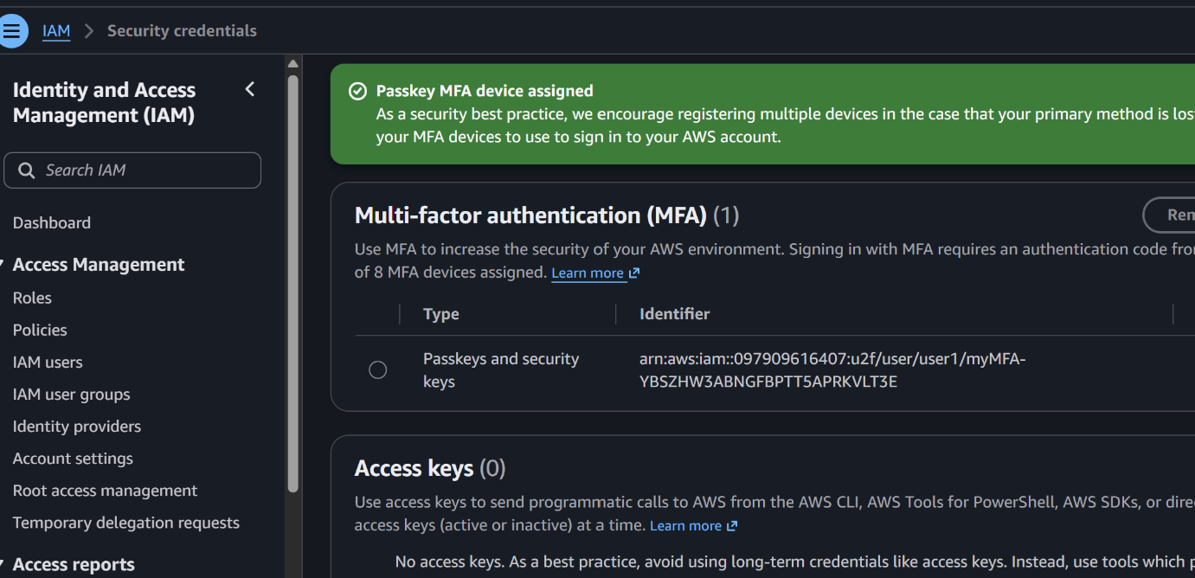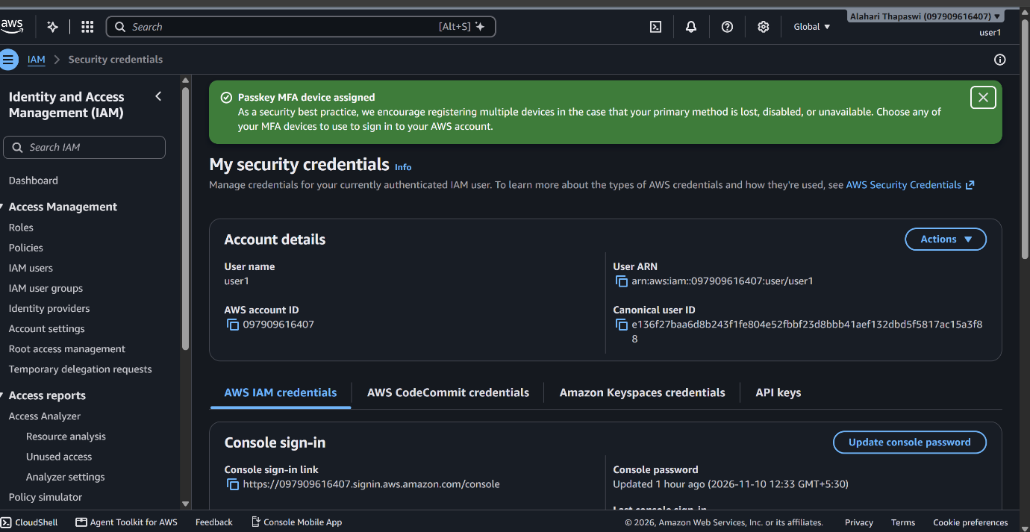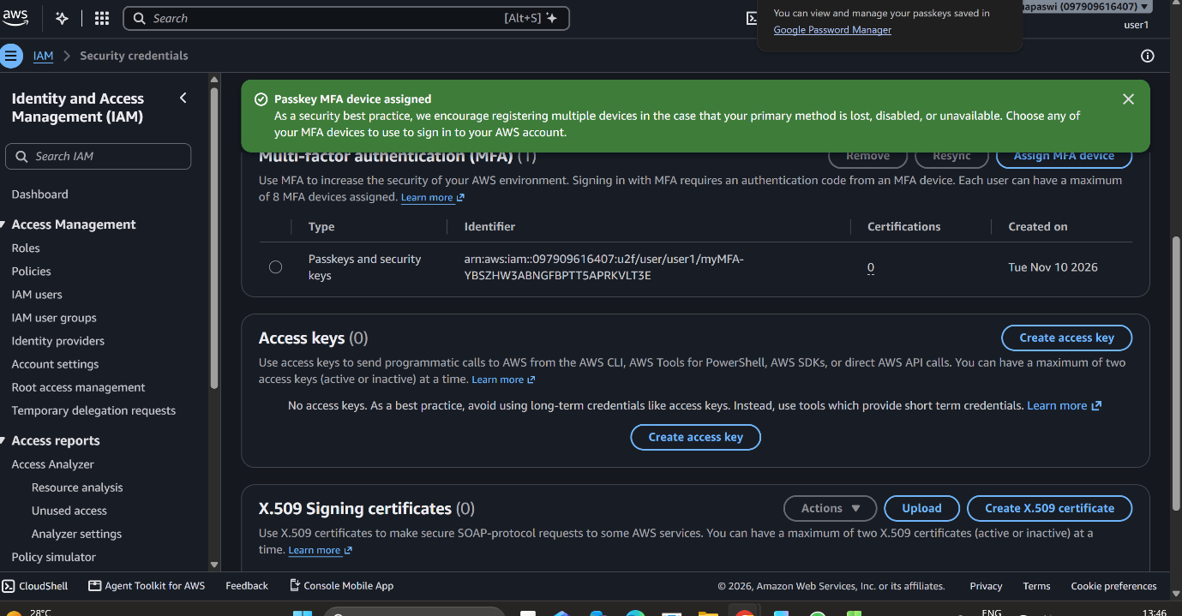
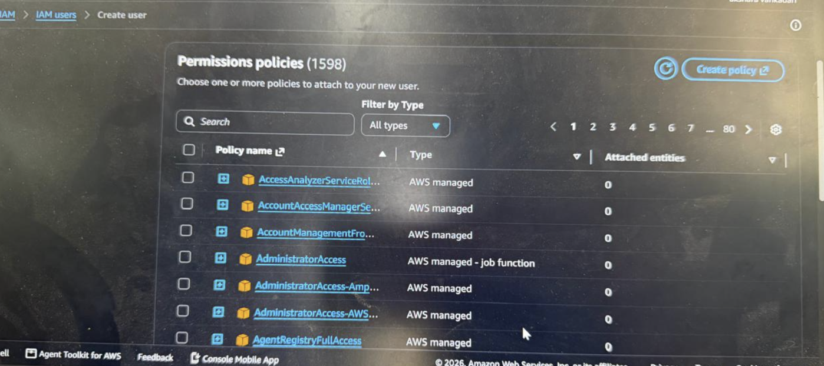

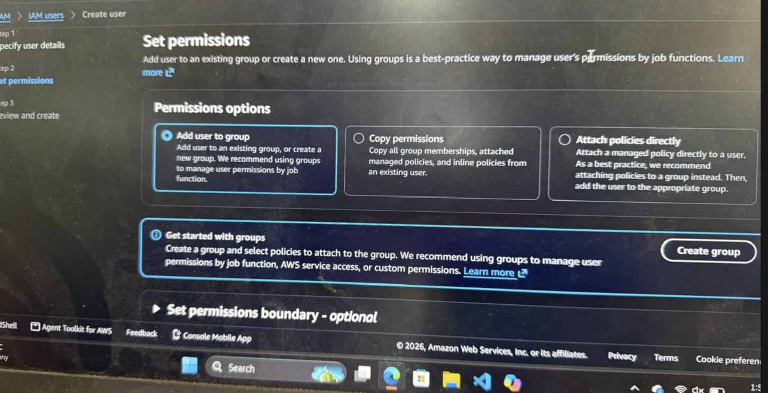

Figure: AWS IAM Security credentials page showing the assigned passkey MFA device.
Additional Screenshot:

Figure: AWS IAM – Set permissions page while creating an IAM user.
MFA Assignment Confirmation:

Figure: AWS IAM Security credentials page confirming that the passkey MFA device was assigned.
Expected Outcome:
• An IAM user is created successfully in AWS.
• The required permissions are assigned to the IAM user.
• Multi-Factor Authentication is enabled for the IAM user.
• The IAM user can securely access the AWS Management Console using the configured MFA method.

